**SOFTWARE VERIFICATION, VALIDATION AND TESTING**

TESTING DOCUMENTATION

Selenium Testing Steam

Prepared by:

**Edin Bajrić**

Proposed to:

**Samed Jukić, Assist. Prof. Dr.**

**Aldin Kovačević, Teaching Assistant**

22.1.2023.

TABLE OF CONTENTS

Contents

1. Introduction 3

1.1. About the Project 3

1.2. Project Functionalities and Screenshots 3

2. Test Plan 6

2.1. Scope 6

2.2. Testing Environment and Tools 6

3. Test Execution 6

3.1. Edit Profile 6

3.2. Adding items to the cart and cart total 8

3.3. Wishlist options 9

3.4. Add game to the Library 11

3.5. Complete tasks to receive a badge 12

3.6. Chat filtering 13

3.7. Change language 14

4. Conclusion 15

4.1. Testing Summary 15

4.2. Final Thoughts 15

# 1. Introduction

## 1.1. About the Project

For this project I am testing Steam. Steam is a video game digital distribution service. Steam allows you to buy games, sell games, play games, and review them, chat with your friends, customize your Wishlist, add items to your cart and much more. It is the most popular digital game store in the world.

Homepage: <https://store.steampowered.com/>

## 1.2. Project Functionalities and Screenshots

**Sign in**

**Search** to find games and software

**Wishlist** items you would like to buy someday

In the **cart** you can see the estimated total of your items and proceed to checkout

**Chat** with your friends

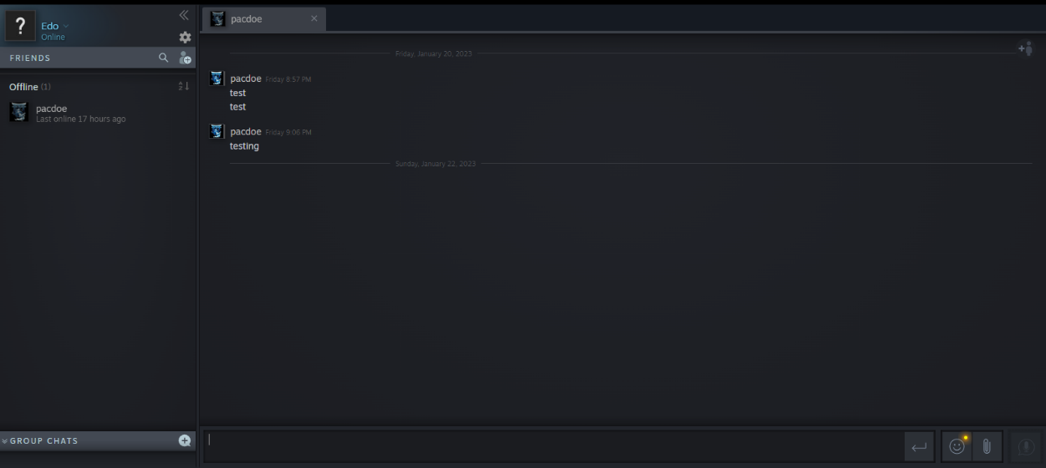

You can see all of the games you own in the **Library**

**Edit your profile**

Manage **account details**

# 2. Test Plan

## 2.1. Scope

My plan is to test the main functionalities of Steam mentioned in the previous section:

* Login
* Search
* Wishlist
* Cart
* Chat
* Library
* Edit your profile
* Account details
* Logout
* And language options

I will avoid testing things which are constantly changing: the front-page content, games which frequently go on sale, reviews, popularity lists, etc.

## 2.2. Testing Environment and Tools

During my testing I will be using Selenium, Junit, and the Java programming language. My IDE of choice is IntelliJ IDEA (Ultimate Edition). For version control I will be using Git and will be committing my project and project documentation to my GitHub repository.

# 3. Test Execution

Note: the login function is called before each test and the logout function is called after each test

## 3.1. Edit Profile

Here we will see if the changes done in the “Edit Profile” settings update our profile with the appropriate information

|  |  |  |  |  |
| --- | --- | --- | --- | --- |
| **Test Name:** Test profile name | | | | |
| **Description:** Check if the profile name updates after change | | | | |
| **Pre-condition(s):** | | | | |
| **Test Steps:**  1. Go to “Edit Profile” and update profile name  2. Save everything  3. Go to user’s profile  4. Check if the profile name is updated | **Test Data:**  New profile name | **Expected Result:**  Inputted profile name | **Actual Result:**  Inputted profile name | **Status:**  PASS |
| **Notes:** | | | | |

|  |  |  |  |  |
| --- | --- | --- | --- | --- |
| **Test Name:** Test country | | | | |
| **Description:** Check if the country updates after change | | | | |
| **Pre-condition(s):** | | | | |
| **Test Steps:**  1. Go to “Edit Profile” and update the country  2. Save everything  3. Go to account details  4. Check if the country is updated | **Test Data:** | **Expected Result:**  Selected country | **Actual Result:**  Selected country | **Status:**  PASS |
| **Notes:** Country needs to be tested in the account details because, on the profile page, the user’s real name and the country are merged together, thus the actual result would be real name + country | | | | |

## 3.2. Adding items to the cart and cart total

The cart is one of the most important features of any store, we will see if it works correctly

|  |  |  |  |  |
| --- | --- | --- | --- | --- |
| **Test Name:** Test cart | | | | |
| **Description:** Check if adding to the cart works and if the total is correct | | | | |
| **Pre-condition(s):** The cart must be populated with items | | | | |
| **Test Steps:**  1. Find first game  2. Enter date of birth to access the game  3. Add the first game to cart  4. Press “Continue Shopping”  5. Find second game  6. Add the second game to cart  7. Test cart total | **Test Data:**  Game names in the search bar | **Expected Result:**  Cart total is the price of first game + price of second game | **Actual Result:**  Cart total is the price of first game + price of second game | **Status:**  PASS |
| **Notes:** | | | | |

## 3.3. Wishlist options

Users want to add games and software to their Wishlist and filter their items however they please

|  |  |  |  |  |
| --- | --- | --- | --- | --- |
| **Test Name:** Test Wishlist price option | | | | |
| **Description:** Check if the “Less than 10€” option in the Wishlist filters items correctly | | | | |
| **Pre-condition(s):** The Wishlist must be populated with items | | | | |
| **Test Steps:**  1. Find first game  2. Add the first game to the Wishlist  3. Find second game  4. Add the second game to the Wishlist  5. Wait for everything to load  6. In the Wishlist options select the “Less than 10€” option  7. Test that the only game left is the one under 10€ | **Test Data:**  Game names in the search bar | **Expected Result:**  Price of the game under 10€ | **Actual Result:**  Price of the game under 10€ | **Status:**  PASS |
| **Notes:** | | | | |

|  |  |  |  |  |
| --- | --- | --- | --- | --- |
| **Test Name:** Test Wishlist type option | | | | |
| **Description:** Check to see if software is the only thing that’s left after changing type option | | | | |
| **Pre-condition(s):** The Wishlist must be populated with items | | | | |
| **Test Steps:**  1. Find software  2. Add software to the Wishlist  3. Find game  4. Add game to the Wishlist  5. Wait for everything to load  6. In the Wishlist options select the type: software  7. Test whether only software is left | **Test Data:**  Software name and game name in the search bar | **Expected Result:**  “Software” tag in the product tags | **Actual Result:**  “Software” tag in the product tags | **Status:**  PASS |
| **Notes:** | | | | |

## 3.4. Add game to the Library

Users should be able to add any game to their Library, that is the most basic functionality of any digital game store

|  |  |  |  |  |
| --- | --- | --- | --- | --- |
| **Test Name:** Test Library | | | | |
| **Description:** Check if the game we chose was added to our Library | | | | |
| **Pre-condition(s):** | | | | |
| **Test Steps:**  1. Find game  2. Add game to the Library  3. Go to the user’s games (Library)  4. Check if the game we added is in the library | **Test Data:**  Game name in the search bar | **Expected Result:**  The title of the game we added | **Actual Result:**  The title of the game we added | **Status:**  PASS |
| **Notes:** | | | | |

## 3.5. Complete tasks to receive a badge

Getting badges for doing basic tasks is a great way to teach the user about the functionality of your page and keep the user interested

|  |  |  |  |  |
| --- | --- | --- | --- | --- |
| **Test Name:** Test badge task | | | | |
| **Description:** Check if the task “Set real name” was completed | | | | |
| **Pre-condition(s):** | | | | |
| **Test Steps:**  1. Go to “Edit Profile”  2. Enter and set real name  3. Save everything  4. Go back to profile and go to badges  5. Go to the “Pillar of Community” badge  6. Test if the task is completed | **Test Data:**  Real name | **Expected Result:**  Task completed | **Actual Result:**  Task completed | **Status:**  PASS |
| **Notes:** | | | | |

## 3.6. Chat filtering

Chat integrated into a game store is a great way to connect to your gaming buddies, but sometimes, if kids are using this feature, we need to make sure that the chat can be appropriately filtered

|  |  |  |  |  |
| --- | --- | --- | --- | --- |
| **Test Name:** Test chat filtering | | | | |
| **Description:** Check if the words we selected are filtered | | | | |
| **Pre-condition(s):** | | | | |
| **Test Steps:**  1. Go to chat  2. Wait for everything to load  3. Open chat with friend  4. Test to see if message is visible  5. Go to account details  6. Add desired word to “Always filter these words”  7. Go to chat again  8. Wait for everything to load  9. Test to see if the message is now filtered | **Test Data:**  Word we want to filter | **Expected Result:**  Word is filtered | **Actual Result:**  Word is filtered | **Status:**  PASS |
| **Notes:** Double click is required to open a chat with a person | | | | |

|  |  |  |  |  |
| --- | --- | --- | --- | --- |
| **Test Name:** Test chat filtering with friends | | | | |
| **Description:** Check if the words we selected are filtered when the “Do not filter text from my Steam Friends” option is selected | | | | |
| **Pre-condition(s):** | | | | |
| **Test Steps:**  1. Go to account details  2. Add desired word to “Always filter these words”  3. Select the “Do not filter text from my Steam Friends” option  4. Go to chat  5. Wait for everything to load  6. Test if the message is visible | **Test Data:**  Word we want to filter | **Expected Result:**  Word is not filtered | **Actual Result:**  Word is not filtered | **Status:**  PASS |
| **Notes:** Double click is required to open a chat with a person | | | | |

## 3.7. Change language

In order for the store to be usable in many parts of the world, it needs to allow its users to change the language

|  |  |  |  |  |
| --- | --- | --- | --- | --- |
| **Test Name:** Test language change | | | | |
| **Description:** Check if the language of the page updates when the language is changed | | | | |
| **Pre-condition(s):** | | | | |
| **Test Steps:**  1. Go to change language  2. Change language  3. Refresh  4. Test to see if the language is changed accordingly  5. Change language back to English | **Test Data:** | **Expected Result:**  The tested element is not in English anymore | **Actual Result:**  The tested element is not in English anymore | **Status:**  PASS |
| **Notes:** | | | | |

# 4. Conclusion

## 4.1. Testing Summary

|  |  |  |  |
| --- | --- | --- | --- |
| **Testing Tool** | **Total Tests** | **Passed Tests** | **Failed Tests** |
| Java, Selenium, Junit | 10 | 10 | 0 |

## 4.2. Final Thoughts

Steam is the most popular digital game store in the world and that kind of status requires everything to work perfectly, and it does! The Steam store is implemented well and I had a great time testing it because all the buttons and features are where you would expect them to be. The only issue that I found was the need to use the double click when opening a chat with a person, but that is only a problem when testing, and not at all when you are using the website normally. All in all, I had a great and bug-free time.